**Technology Stack**

Eclipse IDE for Java Developers (Java Oxygen 2019-12 Version 4.10.0), (Node Development Software plugins)

Open for Innovation KNIME 3.7.1(Plug-in Development software)

**QVX Reader Workflow**

In this KNIME Workflow, the Reader Node reads the different Excel files. The row id’s and column ids are generated in a table used an index number. Our QVX reader reads the files from a specific directory and alters the different data types stored on a modified data table as a QVX file.

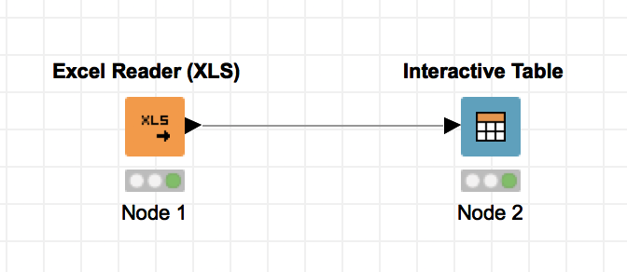

The generated QVX file can read the different field attributes and file specifications required by Qlik View and Qlik Sense in a data table.

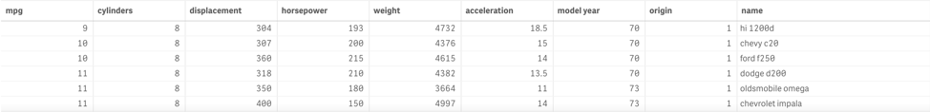

**QVX Reader**

The QVX Reader converts the various data types mentioned in the KNIME data table into specific field attributes that can be read and understood by QVX files.

To use the node, select the QVX file that is supposed to be read. Apply the specified QVX file path to the QVX reader node and convert the different field attributes mentioned in a QVX file to be read as a KNIME data type.

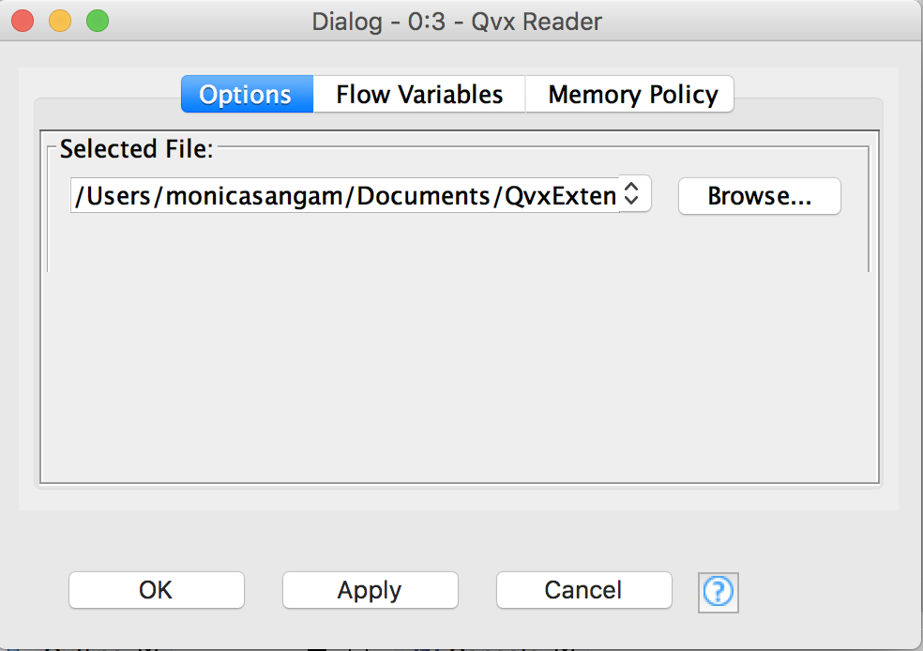

**Contact Us**

For further clarification and questions on how Qlik View and Qlik Sense interacts with KNIME please contact us!

Monica Sangam(Project Manager)

9176452236

Matthew Belanger(Developer)

7323181109

Vidya Analytiq(Mentor)

4804108613

 

About Us

We as a team built and deployed our own KNIME node plugin on Eclipse to handle the different field attributes and file specifications required by Qlik View and Qlik Sense.

QVX files can be read and uploaded on Qlik View or Qlik Sense as CSV (comma separated values), TXT (Text Processing) and XML (Extensible Markup Language). The data that is read on Qlik View and Qlik Sense can be stored in a two- dimensional array or can be read as a table, chart or as a graphic image stored on Excel.